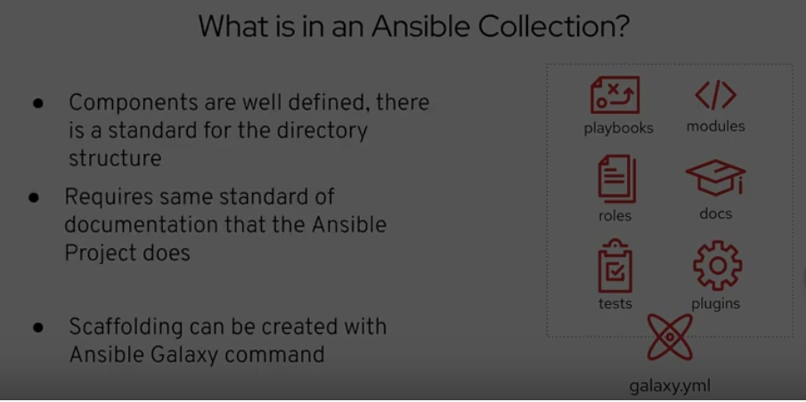

Link: <https://docs.ansible.com/ansible/latest/dev_guide/developing_collections.html>

ansible-galaxy collection build

* This build will generate a tar file which can be used to install collections locally or with in organization.
* The other approach is to upload the ansible collection to galaxy / or to use git to import the collections

### Ansible with Windows

* Lets see how to make ansible work with windows servers 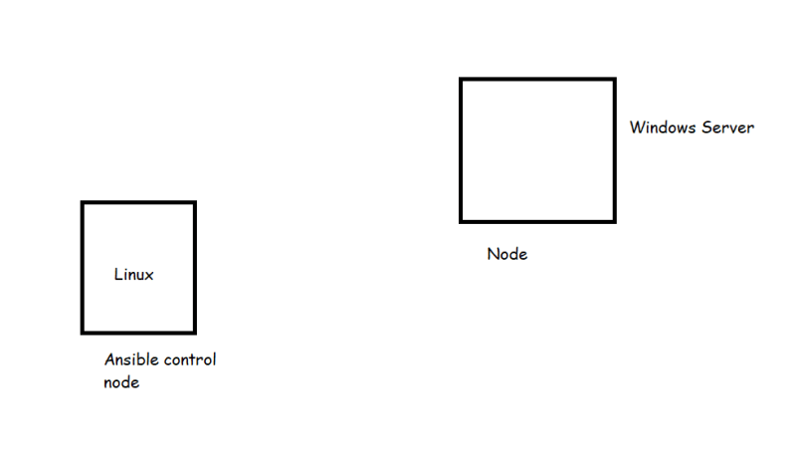
* Ansible winRM protocol to establish connection with Windows Hosts
* Ansible requires Powershell 3.0 or newer and atleast .net 4.0
* Install ansible on the control node
* Login into the Windows Node
* Launch Powershell as Admin and try to execute the following steps

$url = "https://raw.githubusercontent.com/ansible/ansible/devel/examples/scripts/ConfigureRemotingForAnsible.ps1"

$file = "$env:temp\ConfigureRemotingForAnsible.ps1"

(New-Object -TypeName System.Net.WebClient).DownloadFile($url,$file)

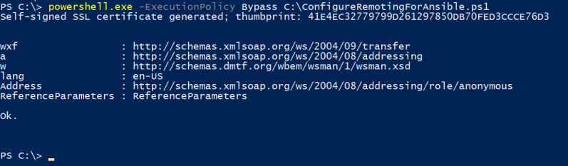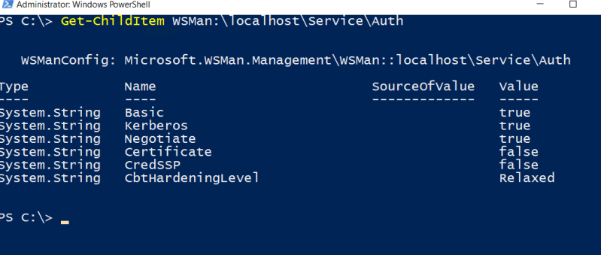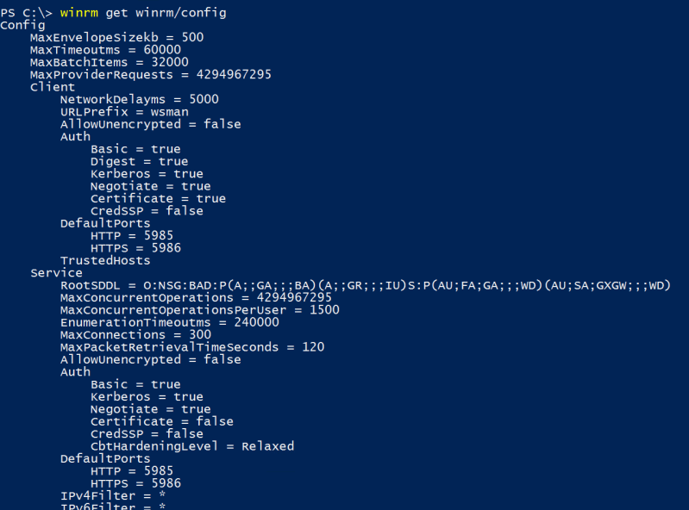

* Now on the ansible control node install pywinrm

pip install pywinrm

* Now created inventory as shown below and execute the win_ping 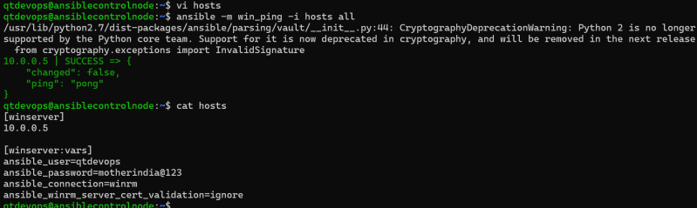
* For working with windows server [Refer Here](https://docs.ansible.com/ansible/2.8/modules/list_of_windows_modules.html) for the windows modules
* [Refer Here](https://github.com/asquarezone/AnsibleZone/commit/de86efeb6685f60f9a2797202618f57e6fb76abe) for the sample playbook created to enable windows server
* [Refer Here](https://github.com/asquarezone/AnsibleZone/commit/588fea55bf7f3c881993508551b3a32908072238) for the corrected playbook 